# 4.1 Vector Spaces and Subspaces

## Vector Space

Definition:

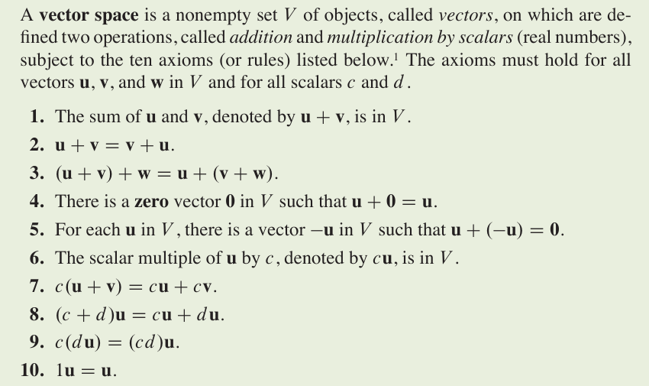

Simple facts:

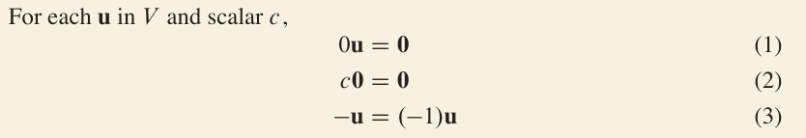

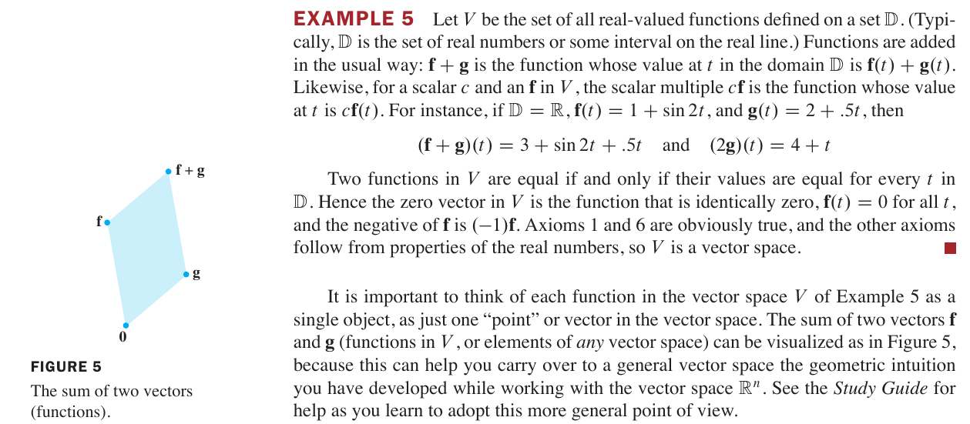

## Subspaces

Definition:

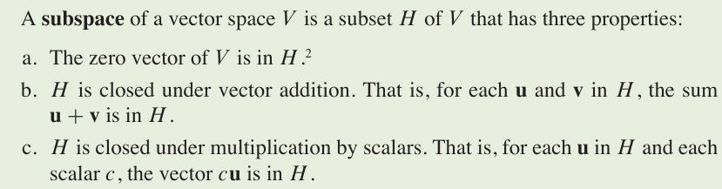

## A Subspace Spanned by a Set

### Theorem 1

We call Span **{v1 , … , vp}** the subspace spanned (or generated) by **{v1 , … , vp}**. Given any subspace *H* of *V*, a **spanning** (or **generating**) **set** for *H* is a set **{v1 , … , vp}** in *H* such that *H =* **{v1 , … , vp}**.

# 4.2 Null Spaces, Column Spaces, and Linear Transformations

## The Null Space of a Matrix

**Definition:**

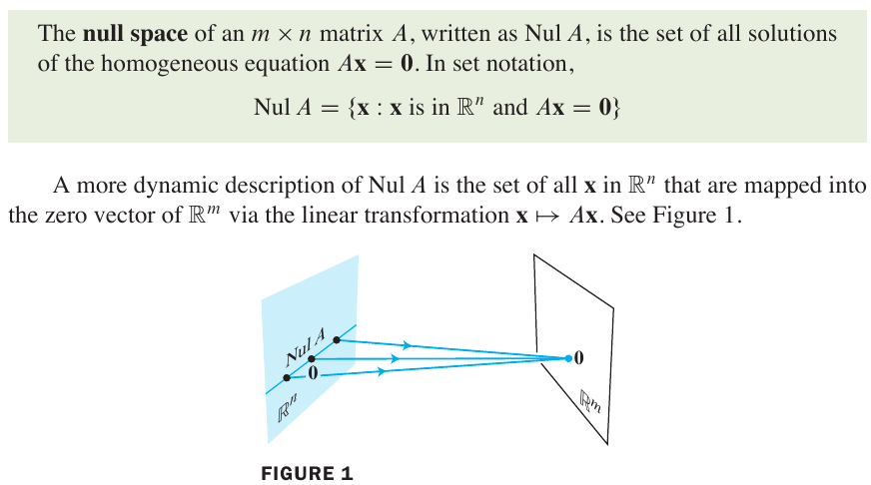

### Theorem 2

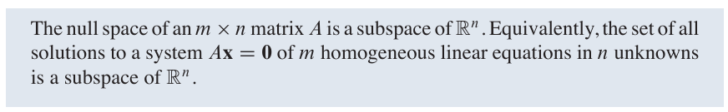

## The Column Space of a Matrix

**Definition:**

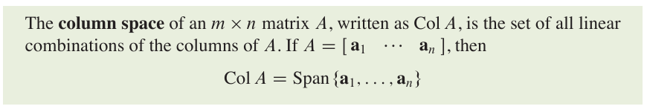

Since Span{**a**1, … , **a**n} is a subspace, by Theorem 1, the next theorem follows from the definition of Col *A* and the fact that the columns of *A* are in ℝn.

### Theorem 3:

Recall from Theorem 4 in Section 1.4 that the columns of *A* span ℝm if and only if the equation *A***x *=* b** has a solution for each **b**. We can restate this fact as folows:

**

## Kernel and Range of a Linear Transformation

**Definition:**

A **linear transformation** *T* from a vector space *V* into a vector space *W* is a rule that assigns to each vector **x** in *V* a unique vector *T*(**x**) in *W*, such that

(i) *T* (**u** + **v**) = *T* (**u**) + *T* (**v**) for all **u, v** in *V ,* and

(ii) *T* (c**u**) = c*T*(**u**) for all **u** in *V*and all scalars *c .*

The **kernel** (or **null space**) of such a *T* is the set of all **u** in *V* such that *T*(**u**) = **0** (the zero vector in *W*). The **range** of *T* is the set of all vectors in *W* of the form *T*(**x**) = *A***x**for some matrix *A* – then the kernel and the range of *T* are just the null space and the column space of *A*, as defined earlier.

# 4.3 Linearly Independent Sets; Bases

### Theorem 4

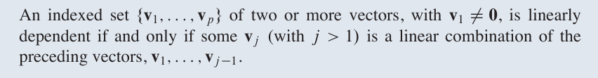

### Basis

**Definition:**

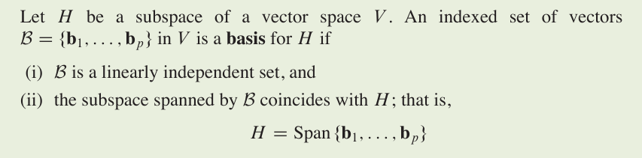

## The Spanning Set Theorem

### Theorem 5

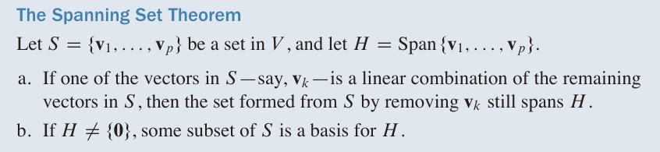

## Bases for Nul *A* and Col *A*

### Theorem 6

The pivot columns of a matrix *A* form a basis for Col *A.*

# 4.4 Coordinate Systems

### Theorem 7

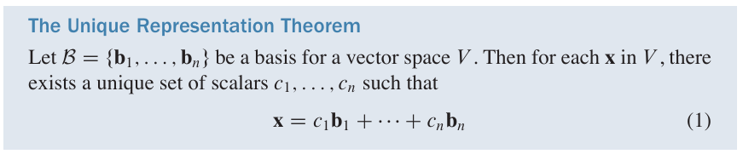

### Definition

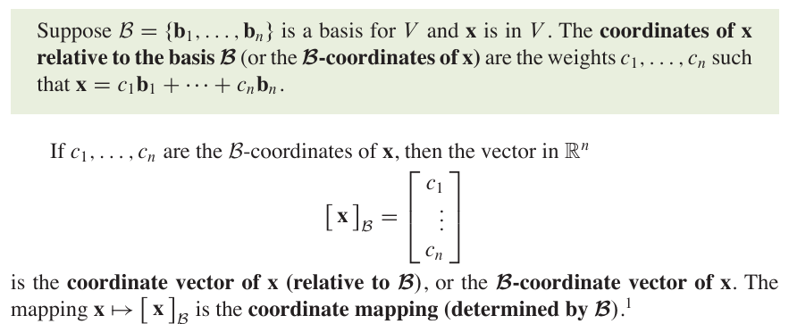

### Theorem 8



# 4.5 The Dimension of A Vector Space

### Theorem 9



### Theorem 10



### Dimension

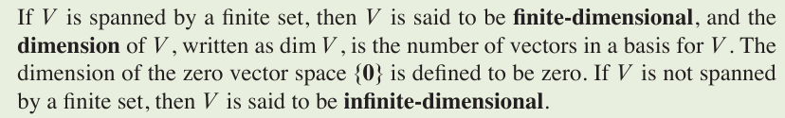

## Subspaces of a Finite-Dimensional Space

### Theorem 11

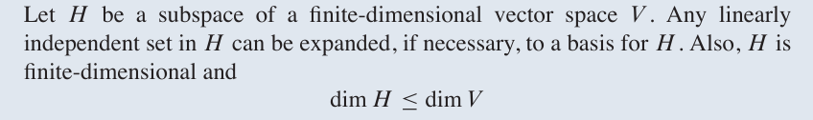

### Theorem 12 – The Basis Theorem

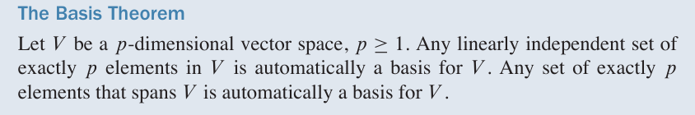

## The Dimensions of Nul *A* and Col *A*



# 4.6 Rank

## The Row Space

### Theorem 13

